Report

Resources for testing

Software (Quote.exe) / hard drive to save text to file / printer or print to pdf options.

Testing plan

- Error Handling

Test Scenario | Test Case | Test Data | Expected Result | Actual Result | Pass/Fail
1.Error Handling | a. Invalid Date entered (invalid month number, rest of form blank, when saving) | See Image 1a | Display Error Message 004 | Displayed Error Message 004 | Pass
 | b. Invalid Date entered (without /, claim in last 5 years = Yes, rest of form blank, when saving) | See Image 1b | Display Error Message 004 | Displayed Error Message 004 | Pass
 | c. Invalid Mileage entered (letters, valid date entered, rest of form blank, when saving) | See Image 1c | Display Error Message 005 | Displayed Error Message 005 | Pass
 | d. Invalid Mileage entered (comma, 2 decimals, valid date entered, rest of form blank, when saving) | See Image 1d | Display Error Message 005 | Displayed Error Message 005 | Pass
 | e. Invalid Mileage entered (comma, 1 decimal, valid date entered, rest of form blank, when saving) | See Image 1e | Display Error Message 005 | Displayed Error Message 005 | Pass
 | f. Invalid Mileage entered (dot, 2 decimals, valid date entered, rest of form blank, when saving) | See Image 1f | Display Error Message 005 | Displayed Error Message 005 | Pass
 | g. Invalid Mileage entered (dot, 1 decimal, valid date entered, rest of form blank, when saving) | See Image 1g | Display Error Message 005 | Displayed Error Message 005 | Pass
 | h. Invalid Mileage entered (alphanumerical, valid date entered, rest of form blank, when saving) | See Image 1h | Display Error Message 005 | Displayed Error Message 005 | Pass
 | i. Invalid Registration Year entered (future year, valid date entered, rest of form blank, when saving) | See Image 1i | Display Error Message 008 | Displayed Error Message 013 | Fail
 | j. Invalid Registration Year entered (year negative number, completed form, when saving) | See Image 1j.1 and lj.2 | Display Error Message 008 | “Do you want to print the quote?” displayed, then displayed Error Message 011 | Fail
 | k. Invalid Registration Year entered (year blank, partially completed form, when saving) | See Image 1k | Display Error Message 008 | Displayed Error Message 008 but with Error Code 014 | Fail
 | l. Registration number must be entered (blank, rest of form blank, when saving) | See Image1l | Display Error Message 013 | Display Error Message 013 | Pass
 | m. Registration number must be entered (just numbers, rest of form blank, when saving) | See Image 1m.1, 1m.2 and 1m.3 | Display Error Message 013 | “Do you want to print the quote?” displayed, then Display Error Message 004, then Displayed Error Message 007 | Fail
 | n. Registration number must be entered (just letters, valid date entered, valid estimated annual mileage, rest of form blank, when saving) | See Image 1n.1 and 1n.2 | Display Error Message 013 | “Do you want to print the quote?” displayed | Fail
 | o. Registration number must be entered (regular registration number, rest of form blank, when saving) | See Image 1o.1 and 1o.2 | Saves without errors | Displayed Error Message 004, then Displayed Error Message 007“ | Fail
- Printing function

Use of printer (image 2a).

- Calculating premium

Test Scenario | Test Case | Test Data | Expected  Results | Actual  Result | Pass/Fail
2.Calculate Premium | Class A-C, Aged less 25  (Comprehensive)  Estimated Mileage (6000)  Claim in last 5 years (no) | Image Below (3a) | £1900.00  £163.3 (with plus £5) | £1900.00  £158.3 | Fail (To correct add £5 to monthly)
 | Class D-E, Aged less 25  (Comprehensive)  Mileage (6000)  Claim in last 5 years (no) | Image Below (3b) | £1500.00  £130 (with plus £5) | £1710.00  £142.50 | Fail (Incorrect calculation details with image)
 | Class A-C, Aged less 25  (Third party)  Estimated Mileage (6000)  Claim in last 5 years (no) | Image  Below (3c) | £900.00  £80 (with plus £5) | £950.00  £79.17 | Fail
 | Class D-E, Aged less 25  (Third party)  Estimated Mileage (6000)  Claim in last 5 years (no) | Image  Below (3d) | £500  £13.33 (with plus £5) | £855.00  £71.25 | Fail (incorrect calculation details with image)
 | Class A, Aged over 25  (Comprehensive)  Estimated Mileage (6000)  Claim in last 5 years (no) | Image  Below (3e) | £1500.00  £130 (with plus £5) | £1520.00  £126.67 | Fail (incorrect calculation details with image)
 | Class A, Aged over 25  (Third Party)  Estimated Mileage (6000)  Claim in last 5 years (no) | Image  Below (3f) | £500  £13.33 (with plus £5) | £760.00  £63.33 | Fail (incorrect calculation details with image)

- Saving to a File

Saving to hard drive (image 4a).

Evidence Log
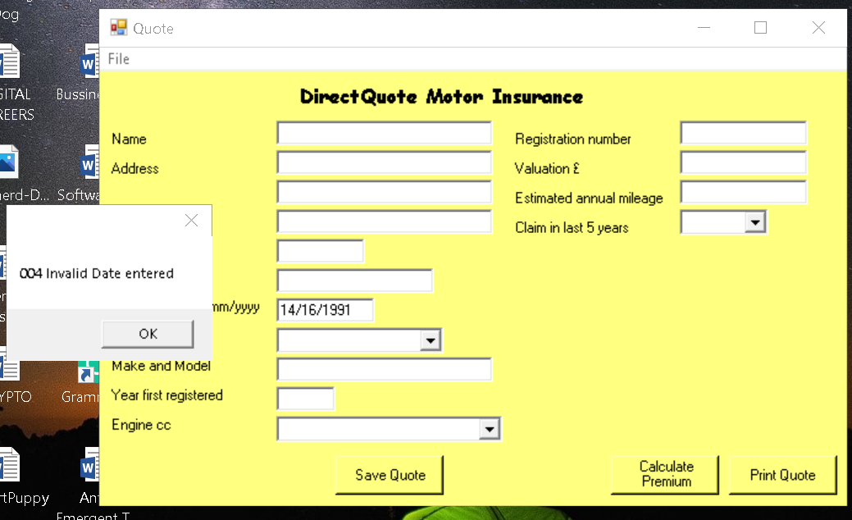1a
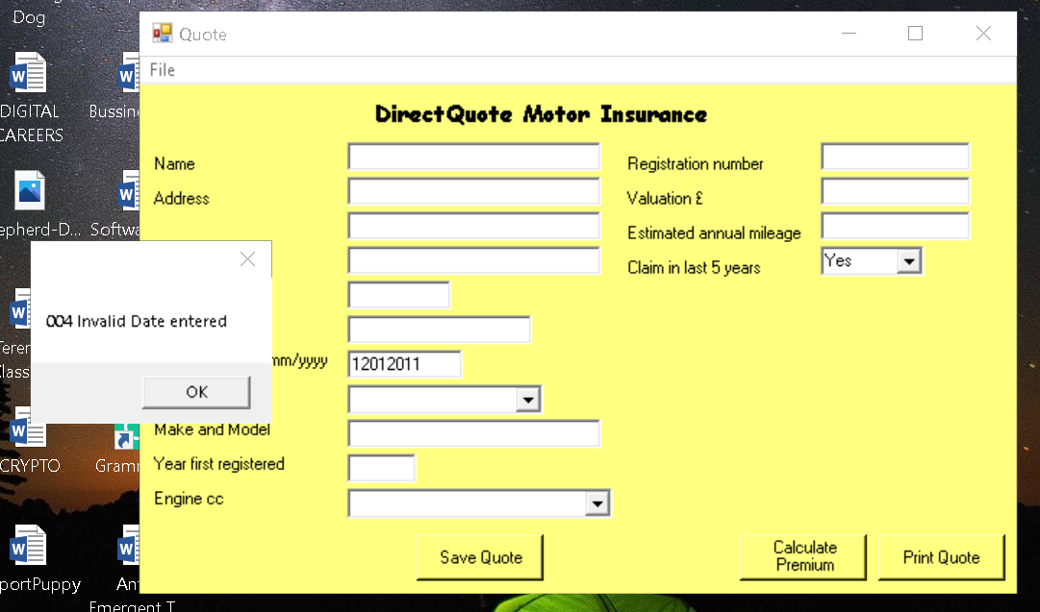1b
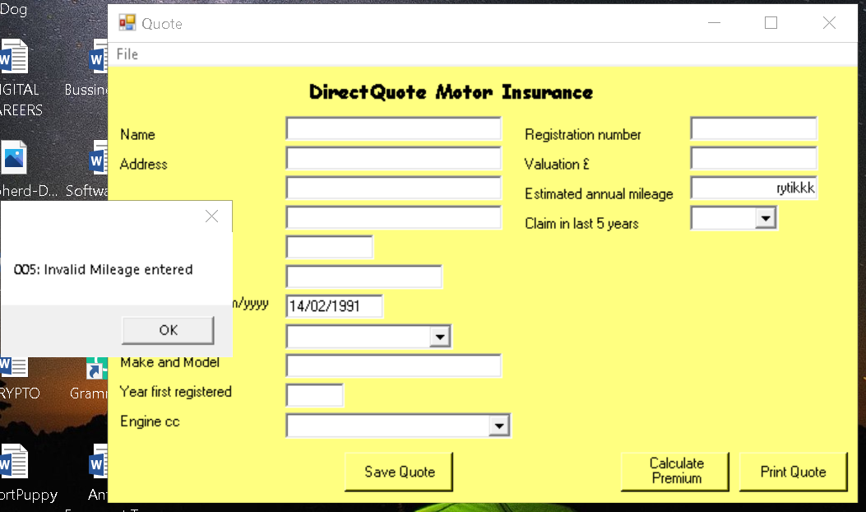1c

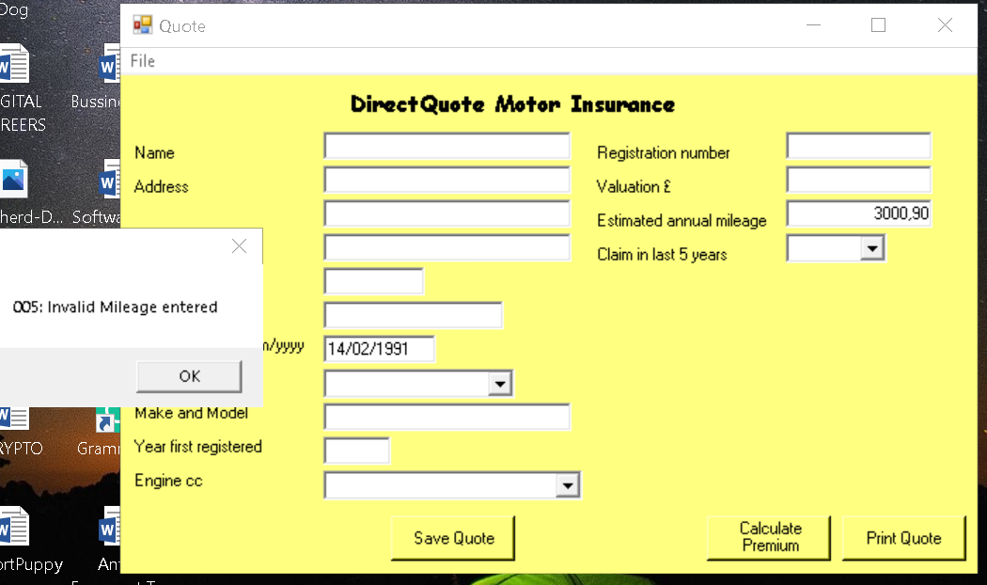1d
1e

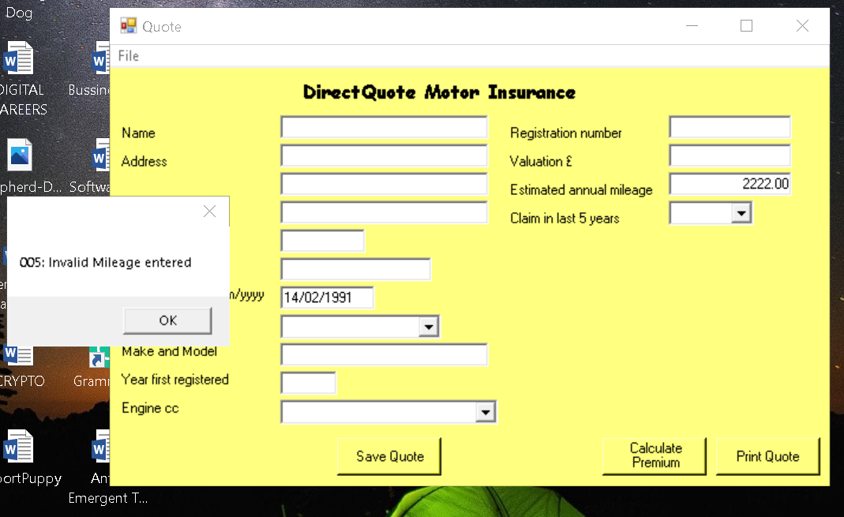1f
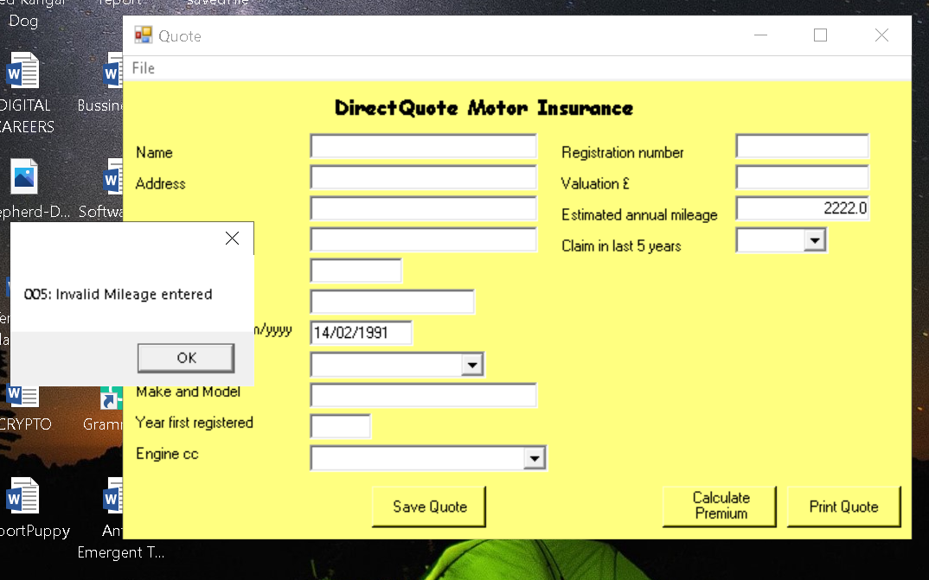1g

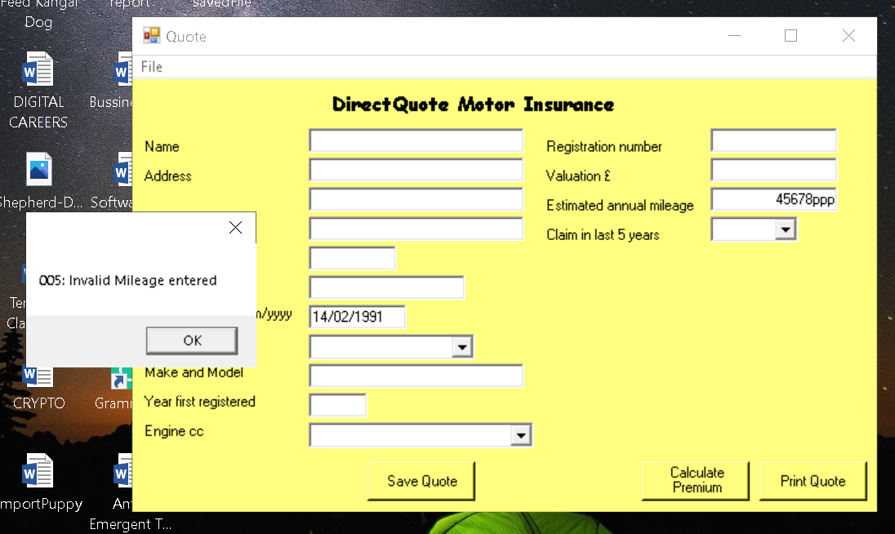1h

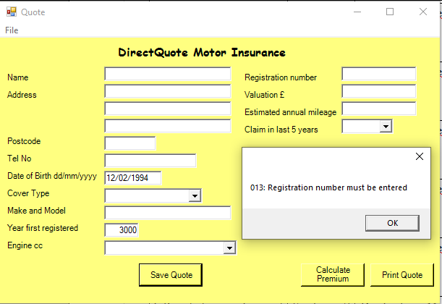1i
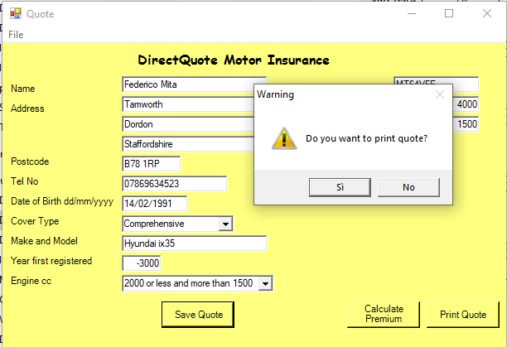1j1

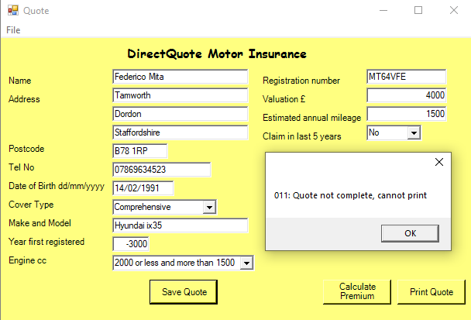1j.2

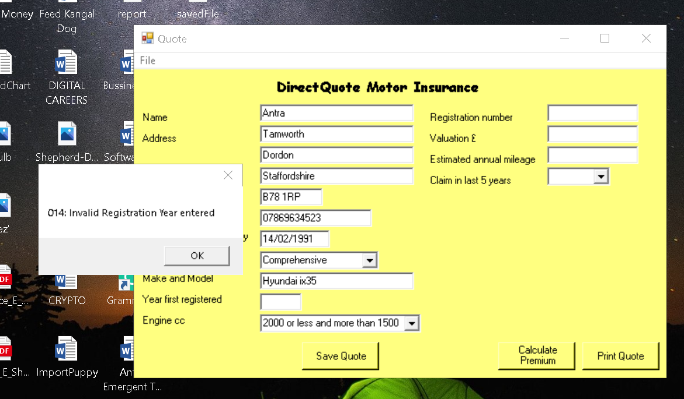1k

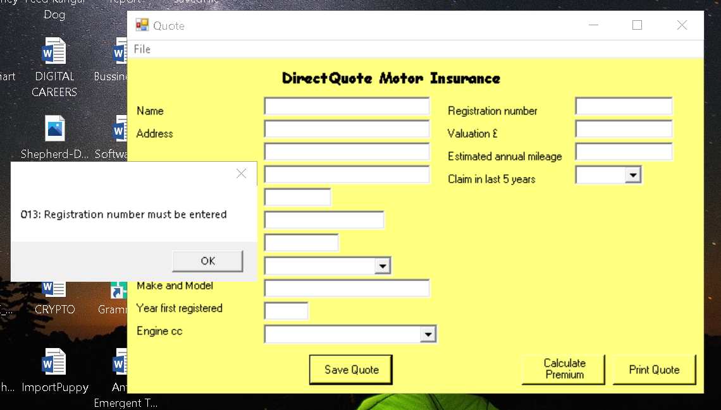1l
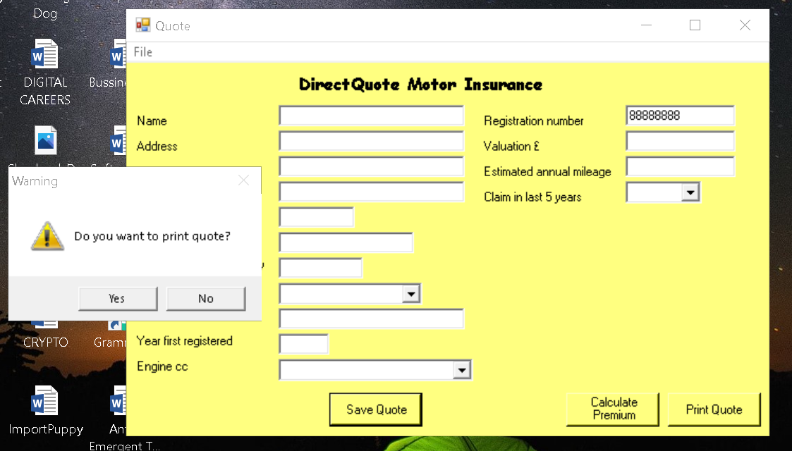1m.1

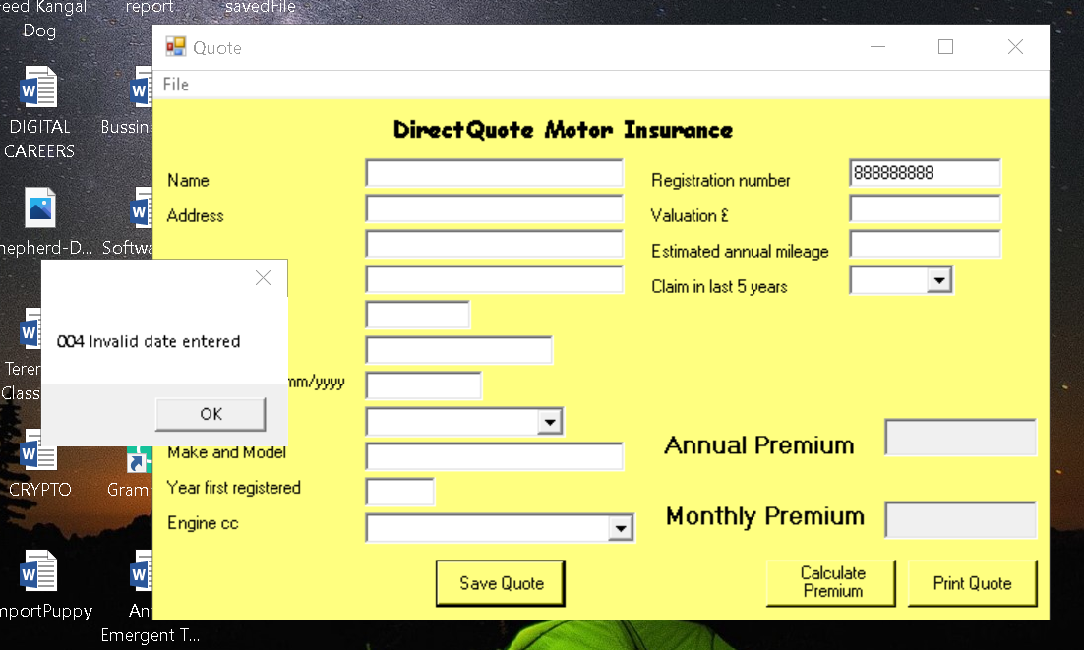1m.2
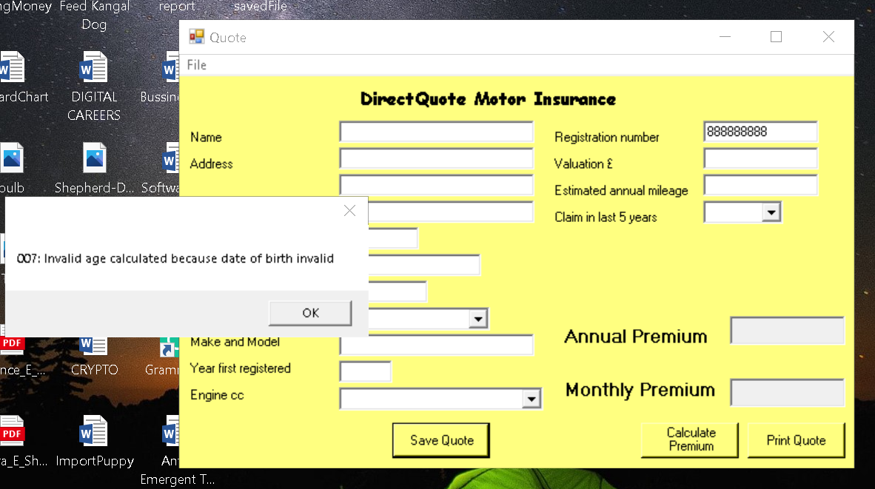1m.3

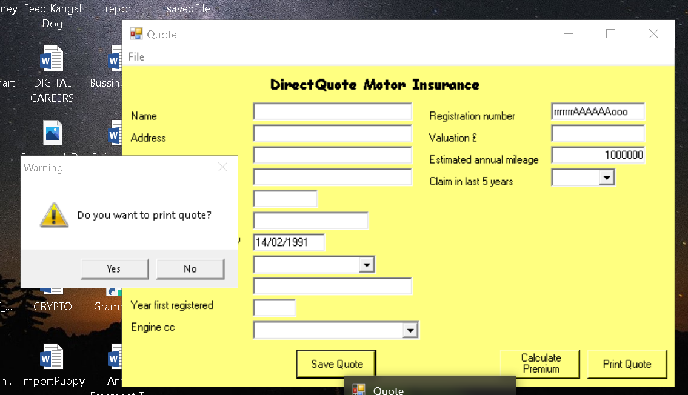1n.1
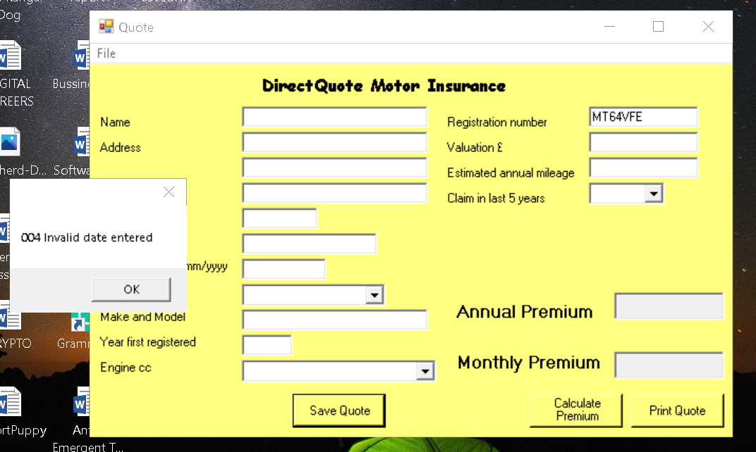1o.1

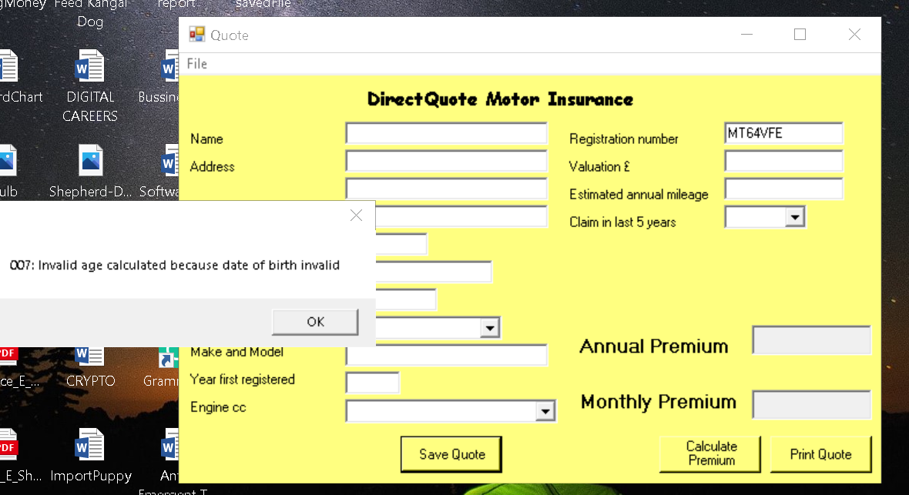1o.2
2a

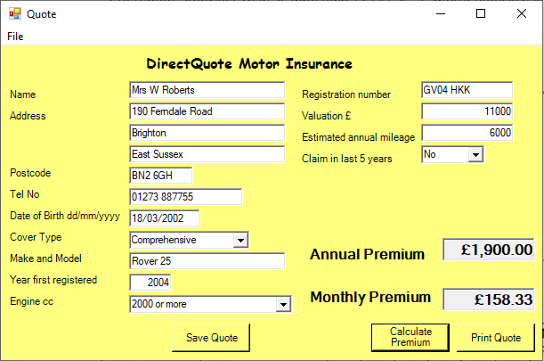3a

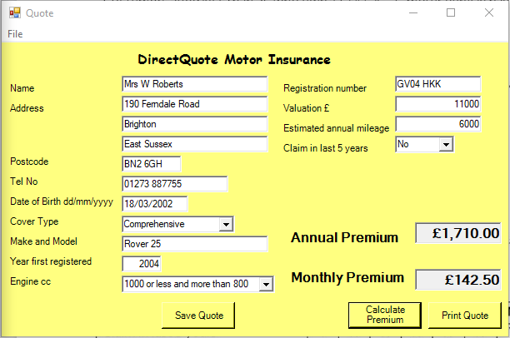3b

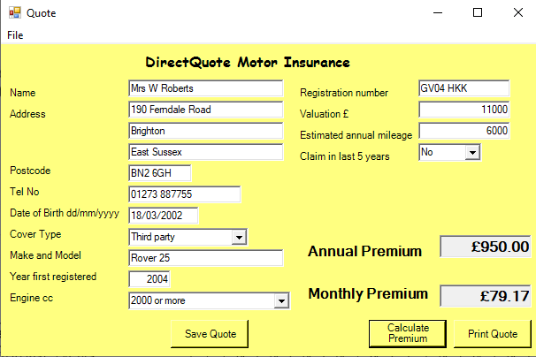3c

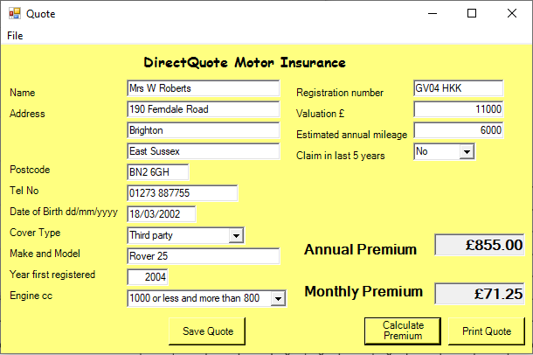3d

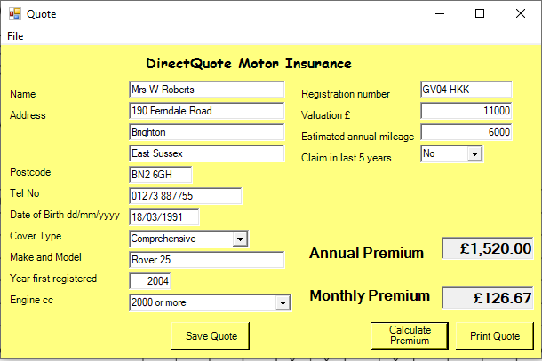3e

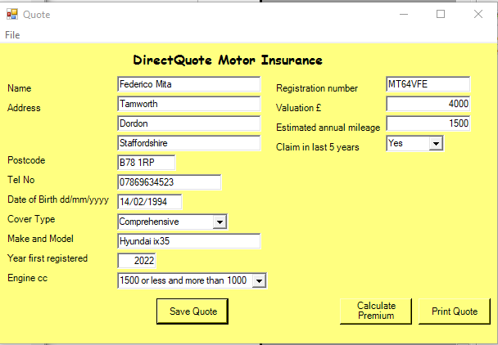4a
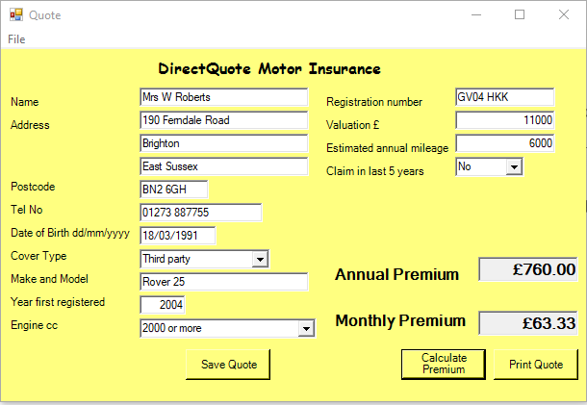3f

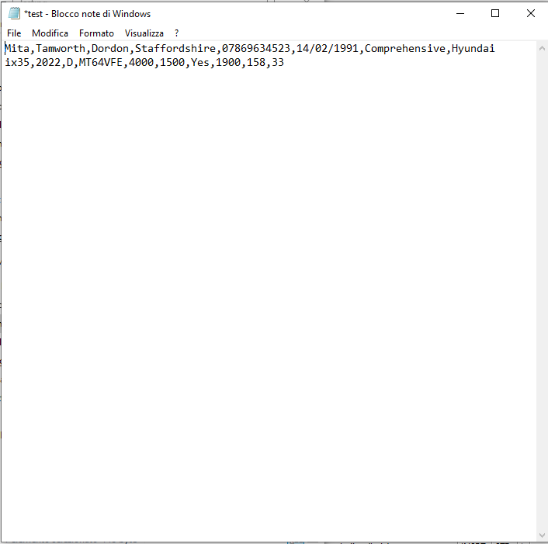4b

Fixing the faults

- Error Handling: the multiple Fails in testing show that not all the “Catch” exception handlers have been properly considered, resulting in multiple “fails” throughout the use of the software. This possibly denotes a poor structural design, considering the sheer multitude of combinations that could result in error. On top of that, even when an error is displayed, in most cases the software still permits saving and printing. Two possible solutions would be: automated unit testings to filter out the majority of the “fails” and a successive “White Box” testing to determine the causes and spot eventual remaining mistakes. After the eventual modifications and improvements, I think it would be advisable to to do a system testing and a “Black Box” testing, to be sure there aren't any remaining issues.
- Calculating Premium: since the consistent mistakes in executing the math functions regarding percentages and the additional £5, I'd say that there is no other solution than for the developers to get back into the code or possibly starting over with a flowchart regarding all the related algorithms, check the business requirements and do some unit testing for the aforementioned functions, than following with an integration testing.
- Printing Function: since there is an element missing (“Make and Model”), there's probably a variable missing from the toPrint function, necessitating in a unit testing to find and fix where the problem lies, then a “Black Box” or an automated testing to check if the problem is gone.
- Save to File: even when all forms are filled correctly and there aren't any errors encountered, the file is saved with the missing postcode. This is probably an omission in the writeTo funcion, requiring a unit testing the find out where is it the mistake and then an automated or “Black Box” testing.
- Extra: it's impossible to save a new form straight after opening the software, even though the is the possibility to save. Instead, a new file needs to be “opened” from the file scroll-down menu. This same funtion-lead event doesn't permit opening an existing file. These things result in a poorly user-friendly application.

Conclusion

The testing was not successfull for two reasons: considering the persistence of “fails”, the “Black Box” testing should have been more in depth, taking into consideration every possible variation and combination of data input into the text-boxes (and possibly using automated testing to help speeding this up); this software is in dire need of a “White Box” testing, to precisely spot where the mistakes in the coding are located and subsequently fix them. After this, even though it's a small software with a very small niche of possible users, it would be advisable to go through a user-lead phase of testing, maybe a “beta”, to spot features that don't work like they should and like the common user would expect them to (like the “open” problem aforementioned).
If this “Black Box” testing would have been thorough, then we could have said that it sadisfactory measured the software's requirements.

